Car Rental Request Automation in ServiceNow

Phase 1 : Service Catalog and Form Design

1. Phase Overview
The primary objective of Phase 1 is to design and configure the user-facing Service Catalog Item within the ServiceNow Service Portal (/sp). This form replaces manual email and phone requests with a standardized digital request intake interface.

2. Configuration Details

A. Catalog Item Metadata
- Item Name: Car Rental Request
- Category: Transportation Services (Service Catalog)
- Target Portal: Service Portal (/sp)
- Short Description: Request a company car for official use

B. Form Variables & Field Specifications
Variable Name | Field Type | Mandatory | Description / Options
To make a request | Reference | Yes | References sys_user table (Default: Logged-in user)
requested_date | Date | Yes | Selects the required rental start date
pickup_location | Single Line Text | Yes | Specifies pickup address/city
drop_location | Single Line Text | Yes | Specifies return address/city
Duration | Radio Buttons | Yes | Options: 1, 2, 3, 4, 5 days
car_type | Select Box | Yes | Options: SUV, sedan, mini
Reason | Single Line Text | Yes | Business justification for the rental
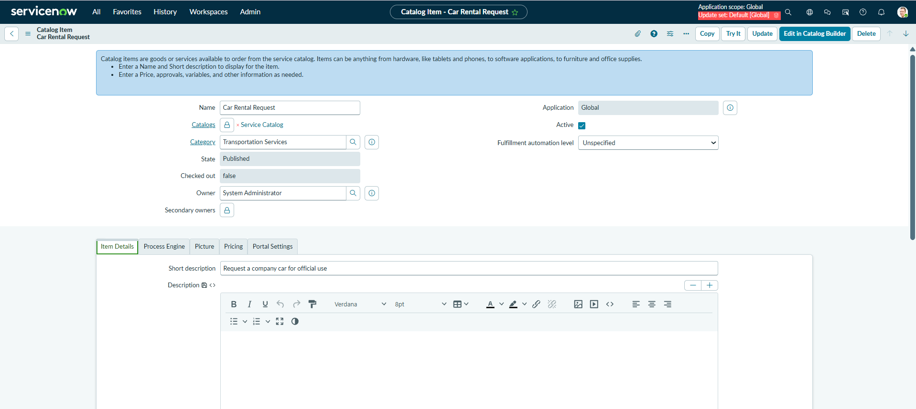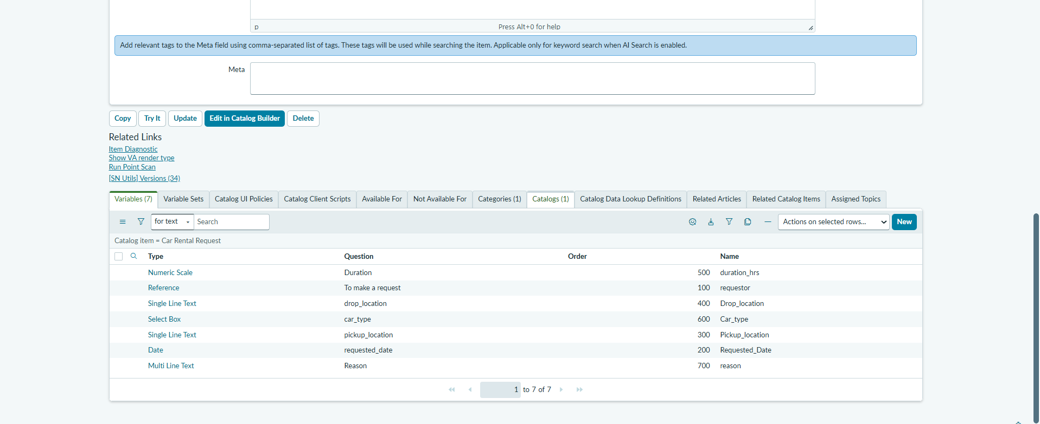
Figure 1.1: Catalog Item Configuration & Form Variables Definition

3. Execution & Verification Steps
- Catalog Creation: Created the Car Rental Request catalog item under the Transportation Services category.
- Variable Setup: Added all 7 core variables with appropriate data types and validation rules.
- Portal Testing: Accessed /sp, searched for "Car Rental Request", and verified form rendering and mandatory field validation.

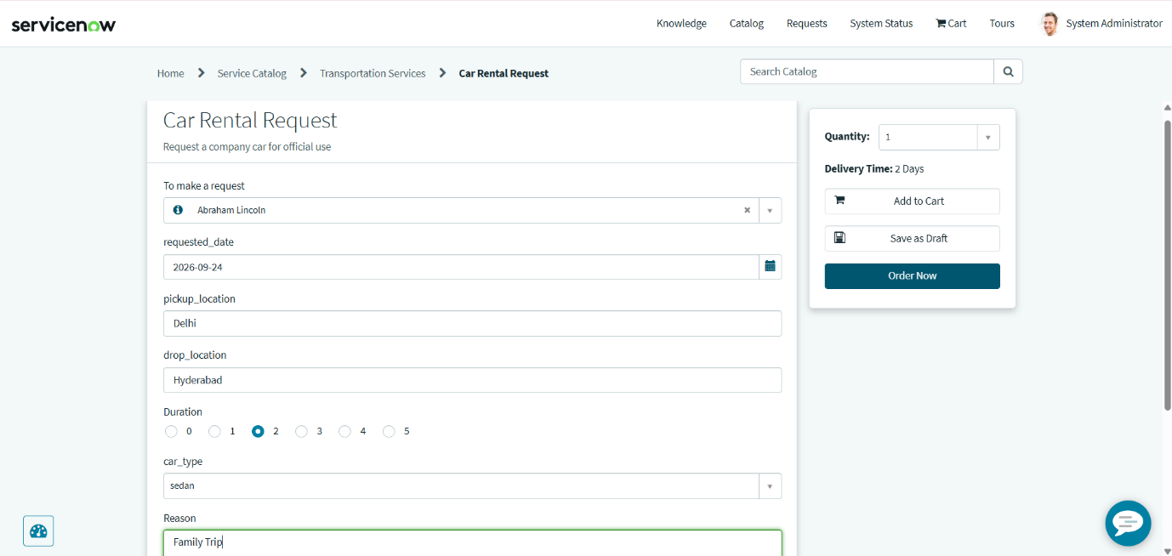
Figure 1.2: End-User Service Portal Live Form View (/sp)

